Year 7 Science

MAKING WATER CLEAN

DESIGN PROBLEM
Running taps, working toilets, and clean, safe drinking water — in Australia, they’re things people can take for granted. Yet around the world, 900 million people do not have access to clean, safe drinking water.

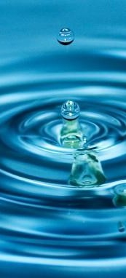

DESIGN BRIEF
Oxfam has approached all Year 7 Science classes at Kew High School to produce a water filtration system that can be used to make dirty water clean.

In this task you will:
- Construct a water purification system
- Complete research tasks

SOME FACTS ABOUT
WATER
- Nearly 1.1 billion people don’t have safe water to drink
- A child dies every 15
seconds from a lack of clean water.
- Though covered with
water, only 3% of earth’s water is fresh water
- 99.7% of earth’s water
is not available for use by humans


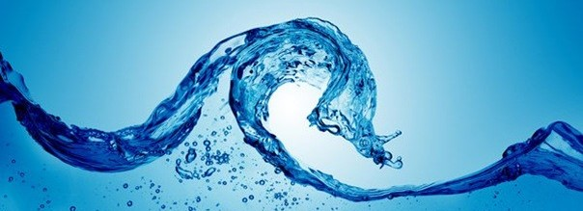
TASK 1: WATER FILTRATION

Design and build a water purification system that cleans water.

The water purification system must:
  - Clean 500mL of dirty water in less than 20 minutes
  - Use at least two separating techniques
  - Be contained in one unit
  - Be built with recycled materials

In your report include:
- An explanation of how the water is being cleaned using correct scientific knowledge.
- A labelled drawing of your water filtration device.
- An explanation of where the recycled materials have come from.

- Evaluate how well your device can filter water. Do this by discussing the strengths and the weaknesses of your device and the clarity of your water.

- A discussion of some of the difficulties you faced completing this project and how did you overcame them.
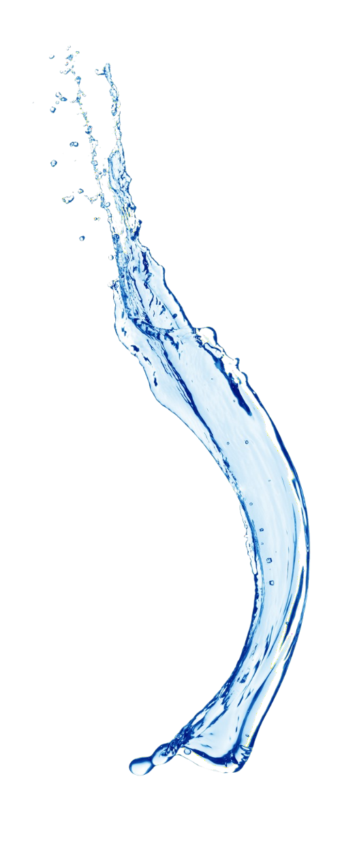

TASK 2: RESEARCH QUESTIONS

Complete the following questions.
1: Explain how different mixtures can be separated.
Include at least three different separation techniques and
include real life applications of these techniques.

2: A mixture contains iron filings, muddy water,
dissolved salt, sand, pebbles. Outline, in order, the steps you
would take to separate this mixture. Identify the techniques
used and explain how they would be used to separate the
specific substance. horse.

Task 3: Ethical Analysis

Why is access to clean water considered a human right and
what are some challenges faced by communities that don’t have
access to it?
In your response:
- Briefly describe why clean water is important for health and
survival. In your response, consider ethical concepts of rights,
responsibilities, equality and non-maleficence.
- Identify which people have the responsibility of
enabling/ensuring access to clean water. What challenges
might these people face in ensuring access?
- Identify at least one country or region where people
struggle to access clean water.

MAKING WATER CLEAN—YEAR 7 SCIENCE CAT 2
Assessment Rubric

Criteria | Emerging 5.5 | Working Towards the Standard  6 | At the Standard  6.5 | Above the Standard  7 | Well Above the Standard  7.5
Science Understanding (Inquiry) | The filtration system was constructed and a diagram was included. | A filtration system and a brief explanation of its design was produced. A diagram was included. The challenges that were faced in the design were outlined. | The design of the filtration system includes effective filtration techniques. A labelled diagram is included. The filter uses recycled materials. The filtration system’s effectiveness was evaluated in terms of strengths and weaknesses. Difficulties that were faced were discussed. | The design is innovative. The filtration system is clearly explained with a detailed matching diagram. The source of recycled materials has been listed. Practical solutions to difficulties faced were implemented. | The design is innovative and works well. The filtration system is comprehensively explained with a matching diagram. The source of recycled materials has been discussed. Improvements for future designs was discussed.
Science Understanding | Different separation techniques that would be used in the scenario were listed. | An explanation of the separation techniques was included. | Explains how three separation techniques would be correctly applied to separate the mixture. | Uses scientific understanding to explain how separation techniques are used to separate the different materials. | Designs a process to separate the mixture in an efficient order using the correct techniques and including an explanation of why they would work.
Ethical Concepts | I can describe the importance of basic ethical concepts like truth and happiness. | I can recognise that people have different opinions about basic ethical concepts. | I can explore increasingly complex ethical concepts like freedom, justice, rights and responsibilities. | I can describe the ways that different understandings of ethical concepts come into conflict | I can describe the connections between fairness, equity, respect and tolerance

